Create any three-tier application using Docker, using a multi-container setup. Build at least one docker image using Dockerfile. You are free to use your old projects, build new projects or take any project from GitHub. However, if you are using a project from GitHub, properly cite the original author of the code in your blog.

1. Write a blog post in a tutorial-like manner, documenting every little step of your work. This blog should include screenshots and explanations. You can include some diagrams, too, if necessary. You are free to make the tutorial in parts. But in such case, part 1 should have a link to part 2 and so on.
2. The blog post should be posted on your own GitHub pages blog. (Search for "How to set up a blog using GitHub pages and Jekyll")
3. The Dockerfile(s) should be uploaded to a GitHub repository, with a Readme file explaining each line of the Dockerfile.
4. As usual, append your roll number to the image/container name. Also, make sure to display your roll number in your presentation tier (front end).
5. You can use any DBMS you like, but I encourage you to use a Database management software which you have not used before.

I will look at the time stamps on your shared GitHub links. The last edit should be within the time limits. Make necessary assumptions if required.

As this exercise is to showcase your skills, write in your language to avoid online plagiarism.

Tutorial

**Create an Isolated Network**

docker network create mongo-network

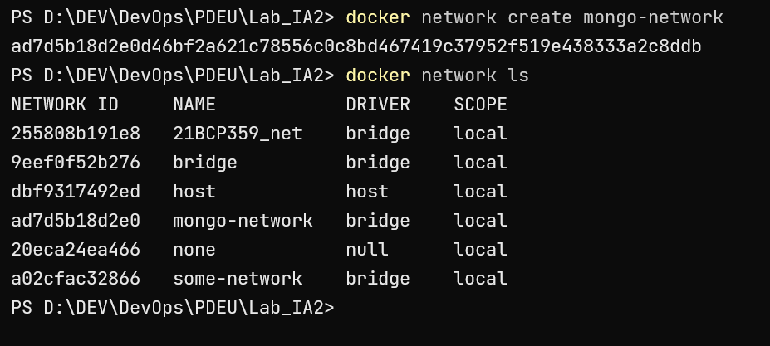

**Creating MongoDB Container**

docker run -p 27017:27017 -e MONGO_INITDB_ROOT_USERNAME=admin -e MONGO_INITDB_ROOT_PASSWORD=password --net mongo-network --name=21bcp359_mongodb -d mongo

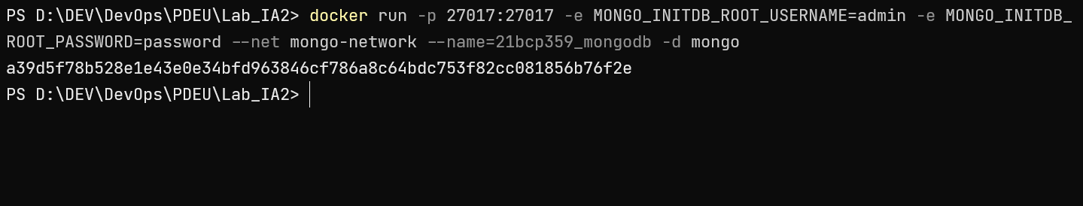

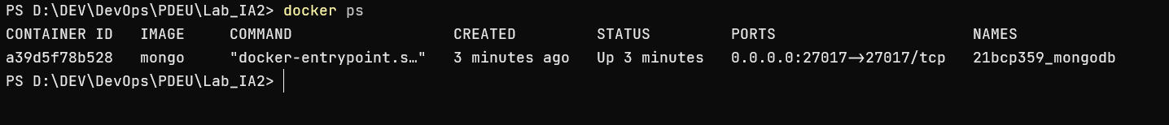

**Creating mongo-express container**

docker run -d -p 8081:8081 -e ME_CONFIG_MONGODB_ADMINUSERNAME=admin -e ME_CONFIG_MONGODB_ADMINPASSWORD=password --net mongo-network --name 21bcp359_mongo-express -e ME_CONFIG_MONGODB_SERVER=21bcp359_mongodb mongo-express

**Create Docker image using Dockerfile**

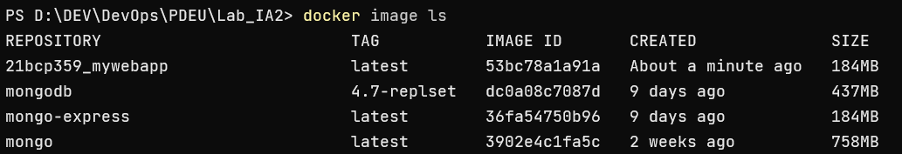

**Run Docker container**

